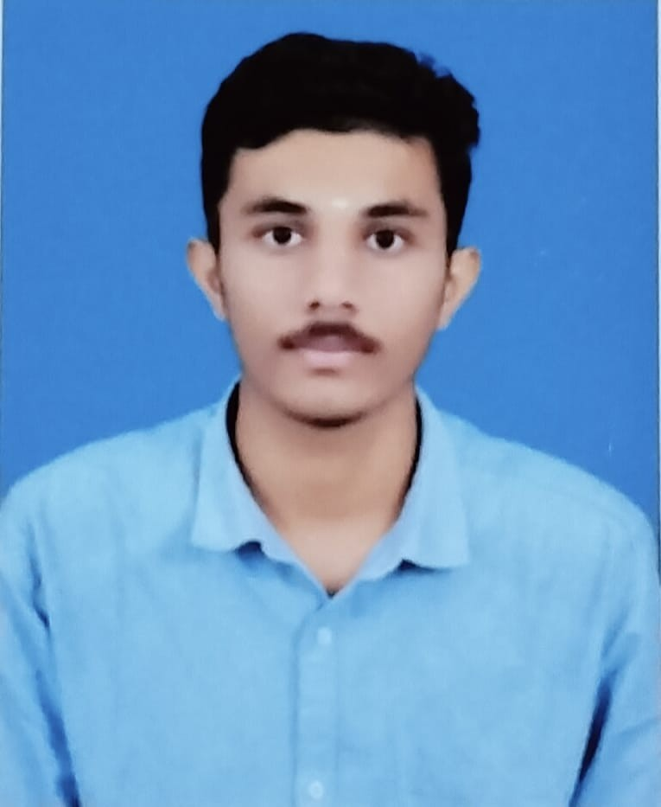Vikas V

Email: [vikasin2005@gmail.com](mailto:vikasin2005@gmail.com) Mobile: 9443656854

# CAREER OBJECTIVE

Work for an organization which provides me the opportunity to improve my skills and knowledge to grow along with the organization objective.

# ACADEMIC QUALIFICATION

|  |  |  |  |  |
| --- | --- | --- | --- | --- |
| **COURSE** | **INSTITUTION** | **UNIVERSITY/BOARD** | **YEAR OF PASSING** | **PERCENTAGE/CGPA** |
| B.E(CSE) | Muthayammal Engineering College (Autonomous) | Affiliated to Anna University,Approved by AICTE | 2024  (Still Pursuing) | 8.0(CGPA) |
| HSC | Vidhya Nikethan matric hr sec  school,Rasipuram,Namakkal district | State Board | 2022-  2023 | 75% |
| SSLc | Vidhya Nikethan matric hr sec  school,Rasipuram,Namakkal district | State Board | 2019-  2020 | All pass |

**TECHNICAL SKILLS**

Languages Known: C,JAVA,DATA STRUCTURE in C Web Technologies: html,css,js

# AREA OF INTEREST

 Web Developement

 Communication skills  Java

# PERSONAL STRENGTHS

 Flexibility

 Sincere and Smart work

 I am interested in learning new things  Good Listener

# PROFESSIONAL PROFICIENCY

 Participated in Paper Presentation of “**Quantum Computing**” in Muthyammal Engineering College Rasipuram

 participated in Paper Prsentation of “”**Network Topology** in Kongu Enginnering College Perundurai

# PERSONAL DETAILS

**Father's Name:** Mr.A.Venkatesan.

**Mother's Name:** Mrs.V.Gowri.

**Address:**25,Nigaanakaradu kattukottai R.pudupatti(po),Rasipuram (tk),Namakkal(dt).

**Language Proficiency:** Tamil (R/W/S),English(R/W/S).

**Date of Birth:**15/12/2005.

# DECLARATION

I hereby declare that all the above information are true and correct to the best of my knowledge. Place:

Date:

(Vikas.V)